**To C**reate a database worker that should contain **first name, last name email, department, salary, Join Date** with 50 employees.

use task;

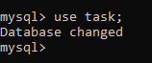

Create table worker(first_name varchar(30),last_name varchar(30),email varchar(30),department varchar(30),salary int,Join_Date date)

insert into worker(first_name,last_name,email,department,

salary,Join_Date) values ('Vinai','kumar','vinaikumar@guvi.com','BAU',13000,'2021-06-13'),

('Vino','Priya','vinopriya@guvi.com','BAU',17000,'2021-07-12'),

('vinoth','selvan','vinothselvan@guvi.com','Ops',21000,'2021-03-13'),

('Ambika','selvi','ambikaselvi@guvi.com','cyber',7000,'2021-02-21'),

('Barathi','Kannama','barathikannama@guvi.com','Analytics',11000,'2021-05-30'),

('Nivetha','NR','nivethanr@guvi.com','BAU',9000,'2021-06-13'),

('Madhan','Bala','madanbala@guvi.com','Ops',18000,'2021-12-12'),

('Kamali','N','Kamalin@guvi.com','BAU',13000,'2021-08-08'),

('Nivi','Nivi','nivinivi@guvi.com','cyber',18000,'2021-11-15'),

('Anu','Priya','anupriya@guvi.com','Ops',16000,'2021-08-13'),

('Mohan','R','mohanr@guvi.com','cyber',30000,'2021-05-12'),

('Vishnu','P','vishnup@guvi.com','Ops',17000,'2021-12-13'),

('Sunil','K','sunilk@guvi.com','BAU',16000,'2021-03-17'),

('Vikram','Khan','vikramkhan@guvi.com','Analytics',27000,'2021-11-13'),

('Merun','k','merunk@guvi.com','cyber',13000,'2021-11-15'),

('Ramesh ','K','rameshk@guvi.com','Analytics',17500,'2021-04-13'),

('Dhoni','ms','dhonims@guvi.com','Analytics',16000,'2021-09-19'),

('Virat','kolhi','viratkolhi@guvi.com','BAU',21000,'2021-11-09'),

('Anu','shree','anushree@guvi.com','Ops',13000,'2021-03-09'),

('Gowtham','Kirshna','gowthamkris@guvi.com','BAU',21000,'2021-04-13'),

('Gowtham ','selvan','gowthamselvan@guvi.com','cyber',13000,'2021-06-13'),

('Sam','Theodar','samtheodar@guvi.com','Ops',12000,'2021-05-13'),

('Ramesh','kumar','rameshkumar@guvi.com','Analytics',20000,'2021-06-17'),

('Santhosh','selvan','santhoshselvan@guvi.com','Ops',2,'2021-06-13'),

('Ashok','selvan','ashokselvan@guvi.com','cyber',15000,'2021-06-13'),

('Ashok','selvan','ashokselvan@guvi.com','cyber',15000,'2021-06-13');

SELECT * FROM worker;

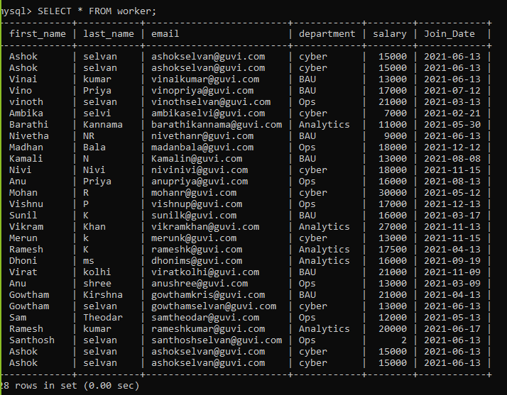

**Task 1**

**#To Write an SQL query to fetch “FIRST_NAME” from the Worker table using the alias name as <WORKER_NAME>**

select first_name as worker_name from worker;

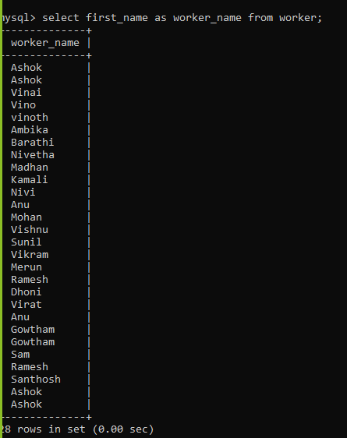

**#To write an SQL query to fetch unique values of DEPARTMENT from the Worker table**

select distinct(department) from worker;

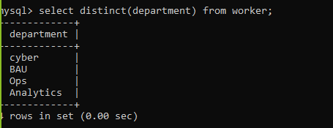

**#To write an SQL query to show the last 5 records from a table.**

select * from worker order by first_name desc limit 5;

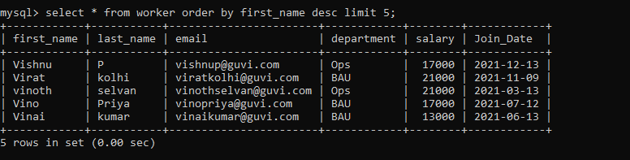

**Task 2**

**#To Write an SQL query to print the first three characters of FIRST_NAME from Worker**

select substring(first_name,1,3) as substring_first_name from worker;

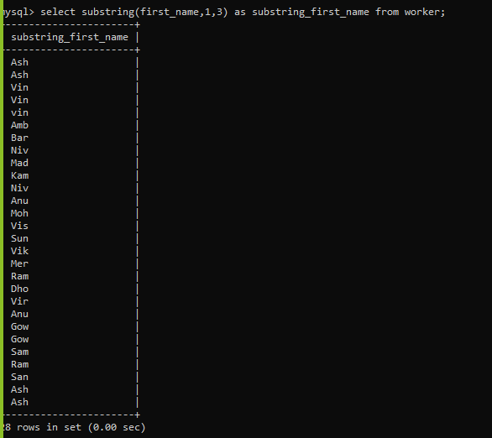

**#To with an SQL query to find the position of the alphabet (‘a’) in the first name**

select position('a' in first_name) as position_a_first_name from worker;

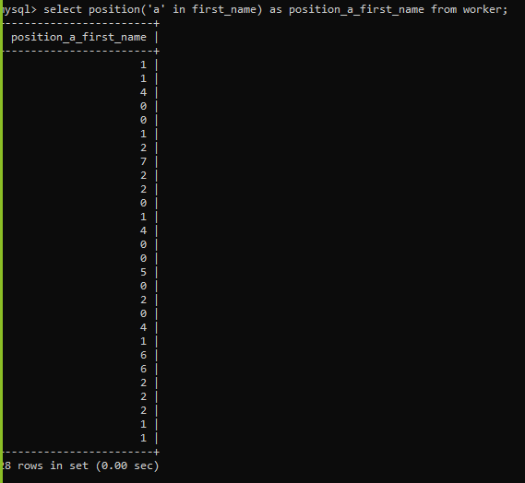

**#To Write an SQL query to print the name of employees who have the highest salary in each department.**

select department,max(salary) from worker group by department;

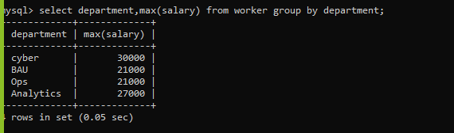

**Task 3**

**#To Write an SQL query to print the FIRST_NAME from the Worker table after removing white spaces from the right side.**

SELECT rtrim(first_name) AS RightTrimmedString from worker;

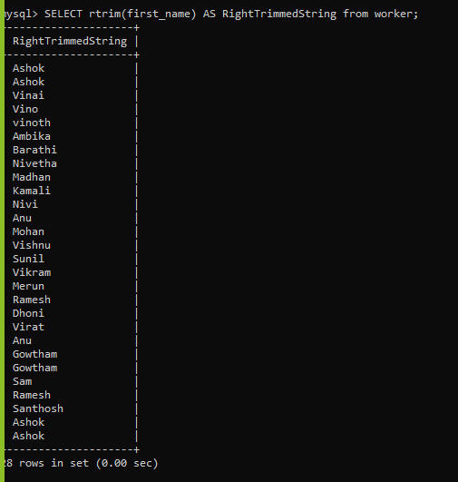

**# To Write an SQL query that fetches the unique values of DEPARTMENT from the Worker table and**

**prints its length.**

select distinct(department), length(department) from worker;

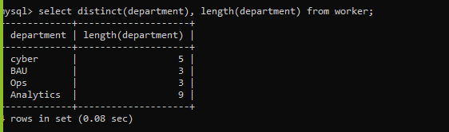

**#To Write an SQL query to fetch nth max salaries from a table.**

select salary from worker order by salary desc;

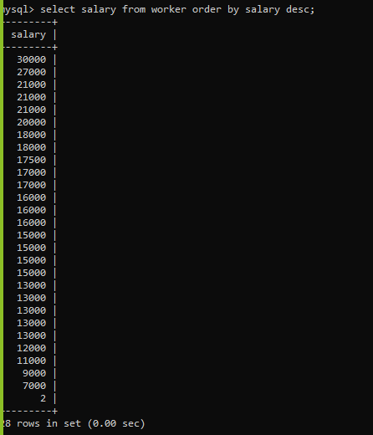

**Task 4**

**# To Write an SQL query to print the FIRST_NAME from the Worker table after replacing ‘a’ with ‘A’**

select replace (first_name, 'a','A') from worker;

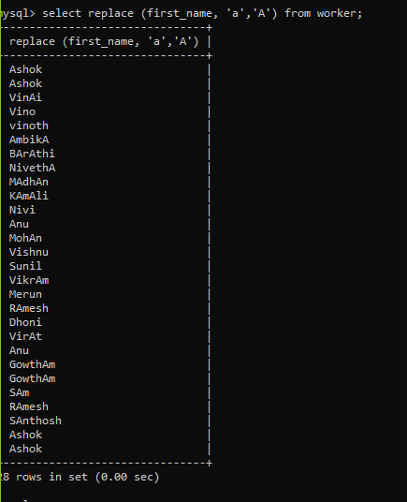

**#To Write an SQL query to print all Worker details from the Worker table order**

FIRST_NAME Ascending and DEPARTMENT Descending.

select * from worker order by first_name asc , department desc;

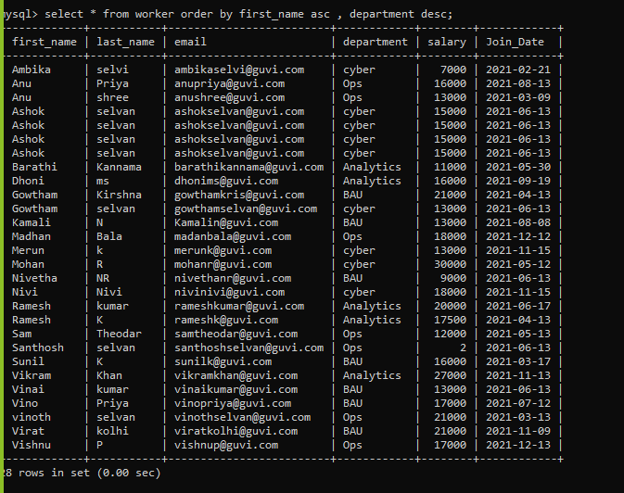

**#To Write an SQL query to fetch the names of workers who earn the highest salary**.

select first_name, salary from worker order by salary desc limit 1;

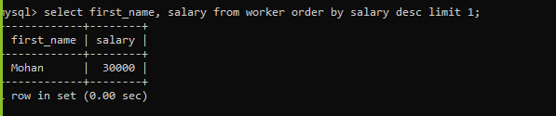

**Task 5**

**#To write an SQL query to print details of workers excluding first names, “Ramesh” and “Santhosh”**

**from the Worker table.**

select * from worker where first_name not in ('Ramesh','Ramesh ', 'Santhosh');

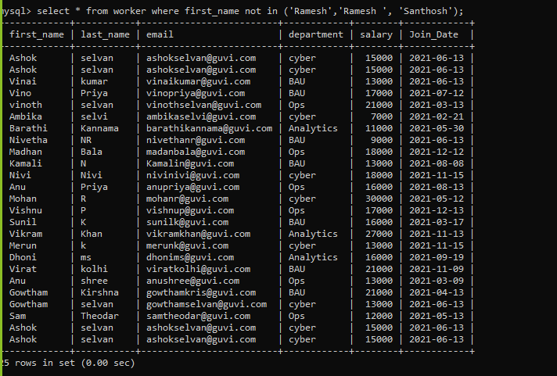

**#To Write an SQL query to print details of the Workers whose**

FIRST_NAME ends with ‘h’ and contains six alphabets.

select first_name from worker where first_name like '_____h';

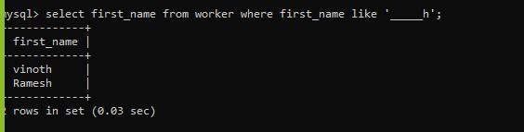

**#To Write a query to validate Email of Employee (email should have first name last name and guvi.com**

example (first name=Kamal last name= raja and the mail id should be kamalraja@guvi.com).

select first_name, last_name, email as Invalid_email from worker

where email not like '%@guvi.com' or

concat(first_name,last_name) != SUBSTRING_INDEX(email,'@',1);

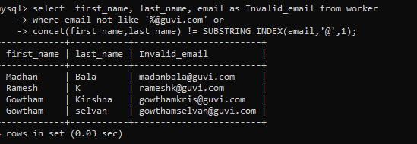

**Task 6**

**#To write an SQL query to print details of the Workers who have joined in March ’2021.**

SELECT * FROM worker WHERE month(Join_date)='03' and year(Join_date) = '2021';

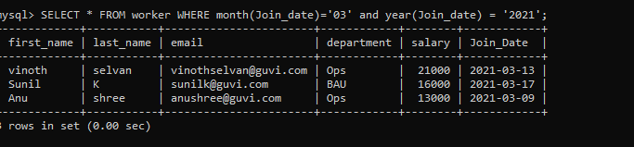

**#To write an SQL query to fetch duplicates that have matching data in some fields of a table**

select * from worker group by email having count(*)>1;

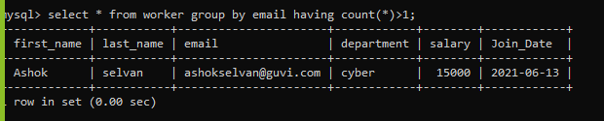

SELECT count(*),email FROM worker group by email;

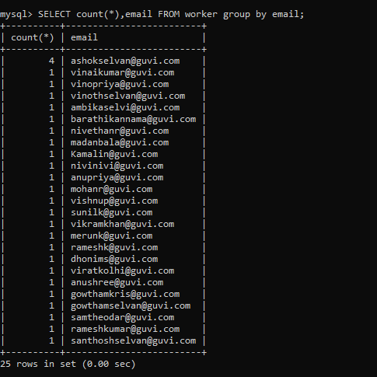

**#To How to remove duplicate rows from the Employees table.**

delete from worker where email not in(SELECT email FROM (SELECT email, ROW_NUMBER()

OVER (PARTITION BY email ORDER BY email) AS row_num

FROM worker) AS worker_table WHERE row_num>1);

select * from worker;

delete email from worker where count(email) > 1;

WITH CTE(firs_tname,

last_name,

email,

DuplicateCount)

AS (SELECT first_name,

last_name,

email,

ROW_NUMBER() OVER(PARTITION BY first_name,

last_name,

email

ORDER BY email) AS DuplicateCount

FROM worker)

select * from CTE;

delete FROM CTE where DuplicateCount > 1;

#To write an SQL query to show only odd rows from a table.

SELECT * FROM (SELECT *, ROW_NUMBER() OVER (order BY email) AS row_num

FROM worker) AS worker_table WHERE row_num%2!=0;

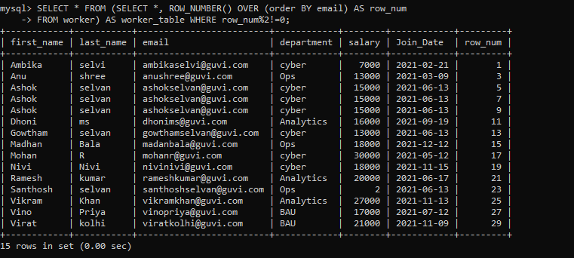

**Task 7**

**#To write an SQL query to clone a new table from another table**

select * FROM (SELECT *, ROW_NUMBER()

OVER (partition by first_name,email order BY email) AS row_num

FROM worker) AS worker_table;

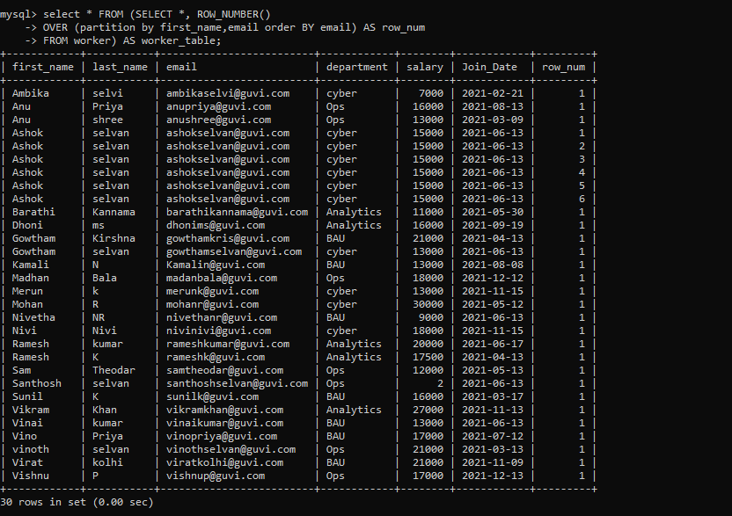

**#To write an SQL query to clone a new table from another table.**

CREATE TABLE worker_employee2 SELECT * FROM worker;

select * from worker_employee2;

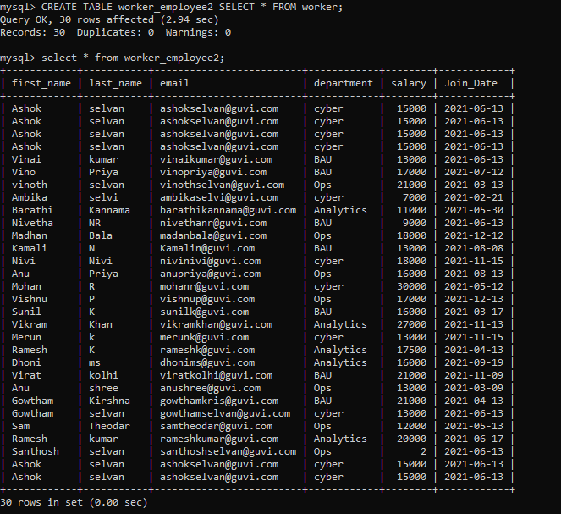

**Task 8**

**#To Write an SQL query to fetch intersecting records of two tables.**

SELECT DISTINCT last_name FROM worker WHERE last_name IN (SELECT last_name FROM worker_employee1);

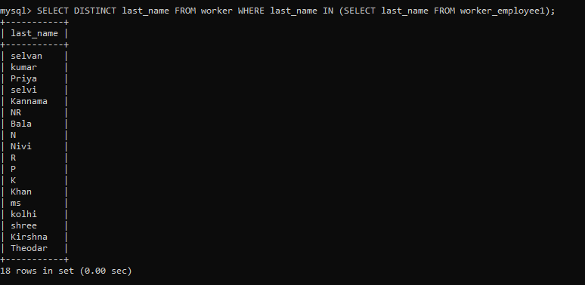

**#To write an SQL query to show records from one table that another table does not have**

SELECT DISTINCT first_name FROM worker WHERE first_name not IN (SELECT first_name FROM worker_employee1);



**Task 9**

**#To Write an SQL query to show the top n (say 15) records of a table.**

select * from worker limit 15;

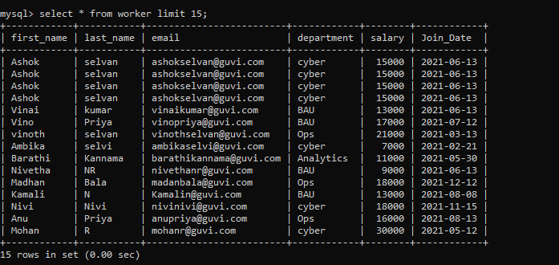

**#To Write an SQL query to determine the nth (say n=10) highest salary from a table.**

SELECT DISTINCT(salary) FROM worker ORDER BY salary DESC limit 11,1;

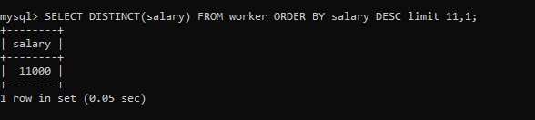

**Task 10**

**#To Write an SQL query to determine the 8th highest salary without using TOP or LIMIT methods**

SELECT * FROM worker w1 WHERE (8) = (

SELECT COUNT( DISTINCT ( w2.Salary ) )

FROM worker w2 WHERE w2.salary >= w1.salary);

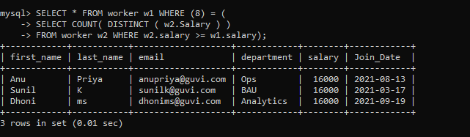

**#To Write an SQL query to fetch the list of employees with the same salary**

SELECT * FROM worker w1 WHERE salary IN (SELECT salary

FROM worker w2 WHERE w1.email != w2.email) order by salary;

